**Questions for Self Study Lesson: Challenge 1 computation**

Please answer the following questions and upload your answers on the course's Moodle page.

**Question 1:** Give an example of a biological process where a flux-balance analysis would not be appropriate (do not use the example given in the self-study material)

**Question 2:** In figure 9 of the self-study hand out, the reactions between the metabolites are represented by a single, one-headed arrow. But, in your biochemistry class you will have learned that chemical reactions are generally reversible.

1. Explain under which conditions it will still make sense to represent biochemical reaction by a one-directional arrow.
2. If you are dealing with a reversible reaction. How could you represent this in the stoichiometry matrix.

**Question 3:** Please set up the stoichiometry matrix that describes the following set of equations.

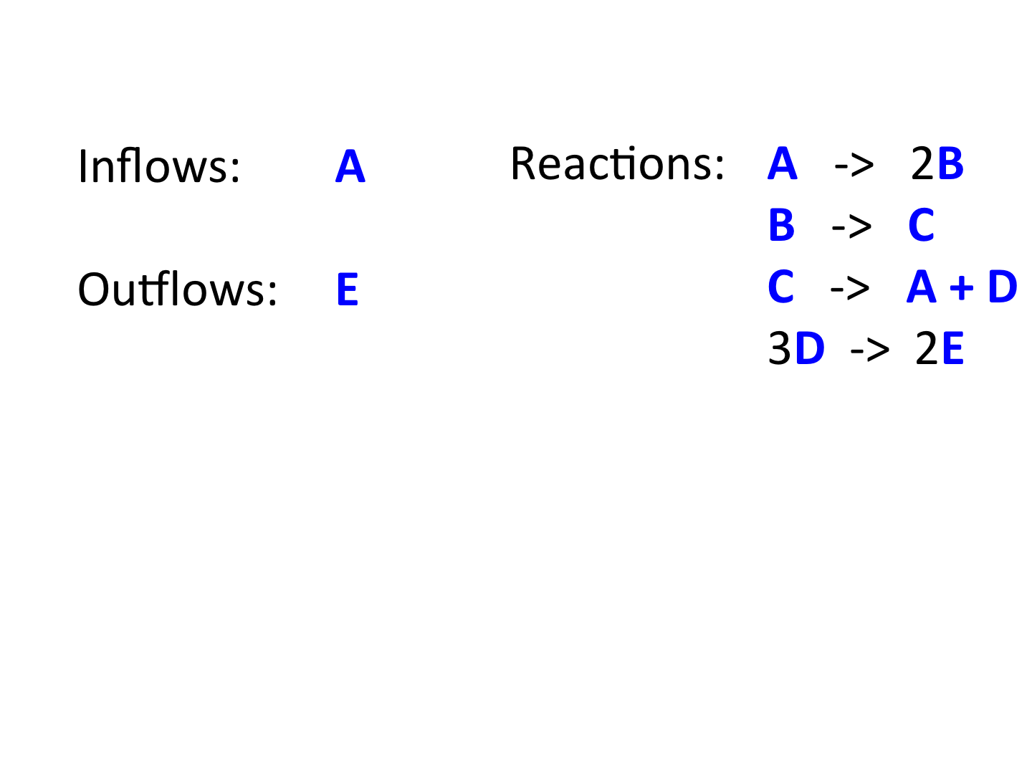

**Question 4:**  In the hand out we discussed how stoichiometric relationships are used as constraints in Flux Balance Analysis. What other constraints could one use in addition?

**Question 5:**  A question for the mathematically savvy. In the example given in figure 11 of the hand out the constraints of the linear programing problem are given in the form of the stoichiometry matrix. How could you include additional constraints in a linear programming problem?

**Question 6:** In Flux Balance Analysis we use the objective function to select out of all possible flux vectors that flux vector which maximizes the objective function. From what you have learned about linear programming, is it possible that two or more flux vectors give the same maximal value?